Question 1: The gardener (with a lot of guidance)

# Opportunity statement

* A gardener has a small plot of land and wishes to plant cabbages and tomatoes. The gardener knows they will get a yield of 1.5 kg of cabbage per meter squared and 2 kg of tomatoes per meter squared. The cabbages require 20 g of fertilizer per meter squared, whereas the tomatoes require 60 g of fertilizer per meter squared.
* A futures contract has been secured allowing the gardener to sell £6/kg of cabbage and £7.5/kg of tomatoes.
* The gardener can only transport 3 kg of produce at time of harvest. The gardener also found only 60 g of fertilizer
* What combination of cabbages and tomatoes should be planted to maximize profits?

# Variables

Let $x_{1}$ be the area of cabbages to be planted and $x_{2}$ be the area of cabbages to be planted.

# Objective function

The objective function is given by the maximum profit:

$$f=6\left(1.5x_{1}\right)+7.5\left(2x_{2}\right)$$

# Constraints

There are two constraints:

1. Fertilizer: $20x_{1}+60x_{2}≤60$
2. Transport weight: $1.5x_{1}+2x_{2}≤3$

# Variable bounds

There are two variables and both variables cannot be negative, i.e.

$$x_{1}≥0$$

$$x_{2}≥0$$

# How to input into MATLAB for the gardener opportunity

Please follow these steps:

1. Into MATLAB type ‘help linprog’
2. Note that linprog minimizes an objective so all objective function must be a minimum,
   1. Write the objective function you need to put into MATLAB
3. Next note that the constraints are put in matrix form, i.e. $Ax≤b$
   1. Construct the matrix for these constraints
   2. Construct the vector for these constraints
4. Note there are no equality constrains so $A_{eq}$ and $B_{eq}$ are both empty (matrix and vector respectively)
5. Note that MATLAB uses $-∞$ as the minimum by default for the variable bounds, so we need to set a new lower bound of 0,
   1. Write the vector that defines the lower bounds on the variable
6. No upper bound has been set so we can assume that it is $∞$ and leave this as the empty vector.

Now write a MATLAB script to solve the gardener opportunity and determine;

1. The area of cabbage to be planted and the area of tomatoes to be planted
2. The weight of cabbage and the weight of tomatoes expected
3. The expected profit

Question 2: Oil refinery (no guidance)

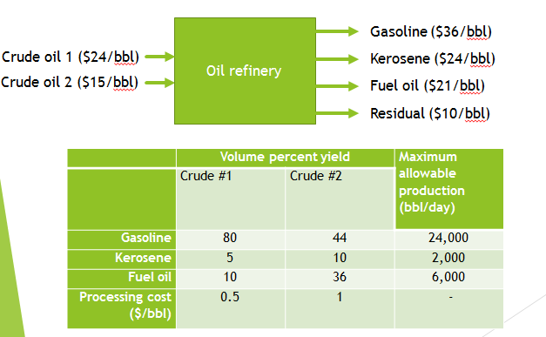

Calculate using MATLAB the amounts of crude oil 1 and crude oil 2 required to optimize the profit.

Question 3: Animal feed mix (a small hint)

An agricultural mill produces animal feed mix by combining limestone, corn and soybeans.

|  |  |  |  |  |
| --- | --- | --- | --- | --- |
| Price and nutrients | Unit contribution | | | Requirements |
| Limestone | Corn | Soybean |
| Calcium (kg/kg) | 0.38 | 0.001 | 0.002 | $≥0.008$, $≤0.012$ |
| Protein (kg/kg) | 0 | 0.09 | 0.5 | $$≥0.22$$ |
| Fibre (kg/kg) | 0 | 0.02 | 0.08 | $$≤0.05$$ |
| Price (£/kg) | 0.1 | 0.2 | 0.4 | - |

(Hint: Calculate the amounts of each unit’s contribution in 1 kg of product).